Hemispherical Segment
# Source: AI Source: Provided by: [Data Path: Persons Table -> ID Column: 1, Name_En Column: Motasem Essam] -> From: [ChatGPT] on [7/25/2026]
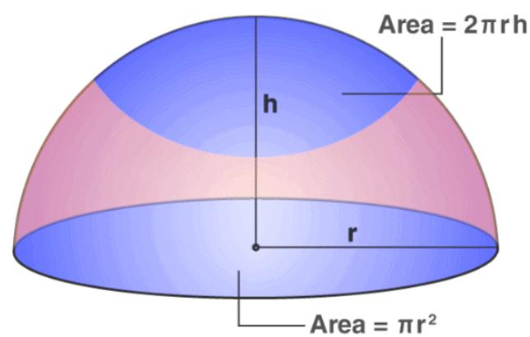

Definition
# Source: AI Source: Provided by: [Data Path: Persons Table -> ID Column: 1, Name_En Column: Motasem Essam] -> From: [ChatGPT] on [7/25/2026]
A hemispherical segment is a solid portion of a sphere associated with a hemisphere and bounded by a spherical surface and one or more planar faces, depending on the precise construction.
The term is not used as consistently as hemisphere, spherical cap, or spherical segment. In standard geometry, a hemisphere is half a sphere cut by a plane through its center, while a spherical segment is the portion between two parallel planes.
Therefore, if hemispherical segment is used to mean a segment that is exactly half a sphere, it is geometrically a hemisphere. If it means a portion of a hemisphere cut by another plane, its exact shape depends on the location of that plane.

Simple Definition
# Source: AI Source: Provided by: [Data Path: Persons Table -> ID Column: 1, Name_En Column: Motasem Essam] -> From: [ChatGPT] on [7/25/2026]
A hemispherical segment is a solid section related to a hemisphere. Its exact meaning depends on how the sphere is cut; the simplest interpretation is a hemisphere, or half of a solid sphere.

Classification and Terminology

A. Hemisphere
# Source: AI Source: Provided by: [Data Path: Persons Table -> ID Column: 1, Name_En Column: Motasem Essam] -> From: [ChatGPT] on [7/25/2026]
One plane passes through the sphere's center and divides the sphere into two equal halves. The resulting solid has one flat circular base.
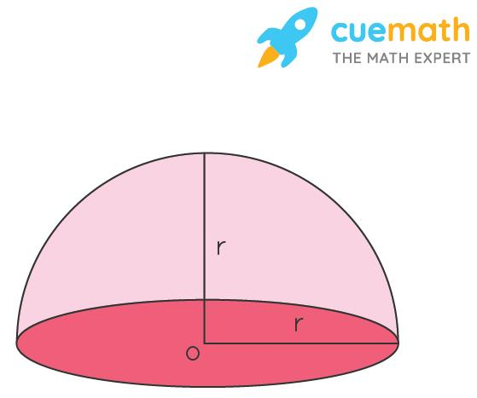

B. Spherical Segment
# Source: AI Source: Provided by: [Data Path: Persons Table -> ID Column: 1, Name_En Column: Motasem Essam] -> From: [ChatGPT] on [7/25/2026]
Two parallel planes bound a portion of the sphere. The solid usually has two circular bases, which may be equal or unequal.
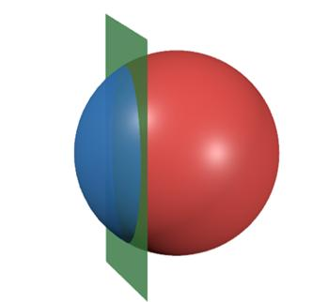

C. Segment of a Hemisphere
# Source: AI Source: Provided by: [Data Path: Persons Table -> ID Column: 1, Name_En Column: Motasem Essam] -> From: [ChatGPT] on [7/25/2026]
An additional plane cuts a hemisphere, producing a smaller solid section. Its dimensions depend on the cutting plane's position.
Terminology note: For a precise mathematics knowledge base, use hemisphere when referring to exactly half a sphere, and spherical segment when referring to a solid between two parallel planes. Use hemispherical segment only when its intended construction has been defined.
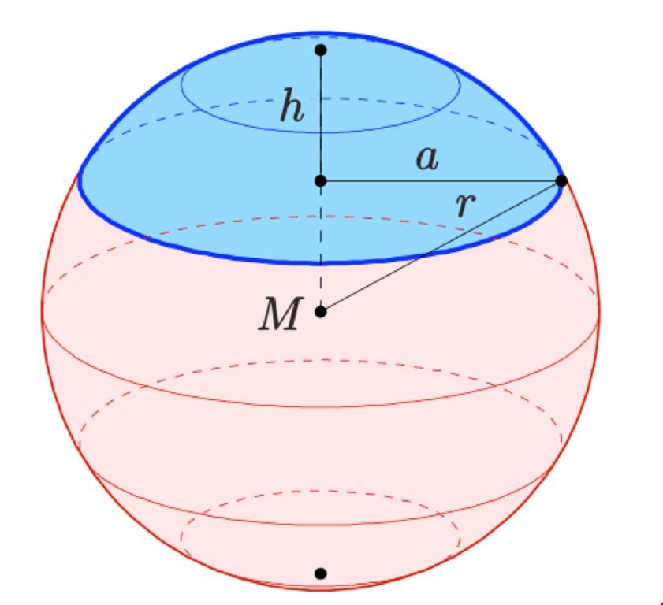

Geometric Elements
# Source: AI Source: Provided by: [Data Path: Persons Table -> ID Column: 1, Name_En Column: Motasem Essam] -> From: [ChatGPT] on [7/25/2026]
For the hemisphere interpretation:
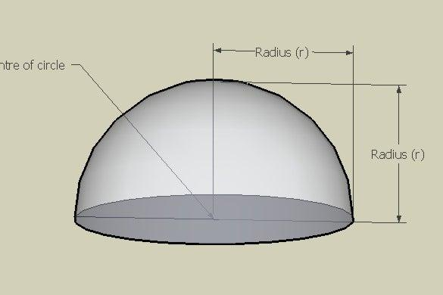
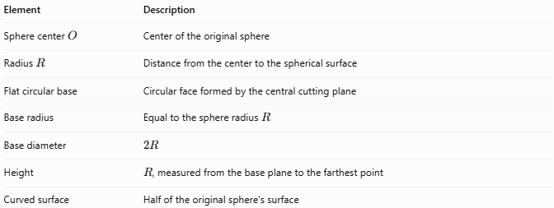
Element | Description
Sphere center $O$ | Center of the original sphere
Radius $R$ | Distance from the center to the spherical surface
Flat circular base | Circular face formed by the central cutting plane
Base radius | Equal to the sphere radius $R$
Base diameter | $$2R$$
Height | $R$, measured from the base plane to the farthest point
Curved surface | Half of the original sphere's surface

Mathematical Properties and Formulas
# Source: AI Source: Provided by: [Data Path: Persons Table -> ID Column: 1, Name_En Column: Motasem Essam] -> From: [ChatGPT] on [7/25/2026]
The following formulas apply when the intended solid is a hemisphere of radius $R$.

Volume
# Source: AI Source: Provided by: [Data Path: Persons Table -> ID Column: 1, Name_En Column: Motasem Essam] -> From: [ChatGPT] on [7/25/2026]
A hemisphere occupies half the volume of a sphere:
$$V=\frac{1}{2}\left(\frac{4}{3}πR^{3}\right)$$
$$\boxed{V=\frac{2}{3}πR^{3}}$$

Curved Surface Area
# Source: AI Source: Provided by: [Data Path: Persons Table -> ID Column: 1, Name_En Column: Motasem Essam] -> From: [ChatGPT] on [7/25/2026]
$$\boxed{A_{c}=2πR^{2}}$$

Flat Base Area
# Source: AI Source: Provided by: [Data Path: Persons Table -> ID Column: 1, Name_En Column: Motasem Essam] -> From: [ChatGPT] on [7/25/2026]
$$\boxed{A_{b}=πR^{2}}$$

Total Surface Area
# Source: AI Source: Provided by: [Data Path: Persons Table -> ID Column: 1, Name_En Column: Motasem Essam] -> From: [ChatGPT] on [7/25/2026]
Including the flat circular base:
$$A_{t}=A_{c}+A_{b}$$
$$\boxed{A_{t}=3πR^{2}}$$

Height and Diameter
# Source: AI Source: Provided by: [Data Path: Persons Table -> ID Column: 1, Name_En Column: Motasem Essam] -> From: [ChatGPT] on [7/25/2026]
$$\boxed{h=R, D=2R}$$

Worked Example
# Source: AI Source: Provided by: [Data Path: Persons Table -> ID Column: 1, Name_En Column: Motasem Essam] -> From: [ChatGPT] on [7/25/2026]
A hemispherical solid has a radius of $6\text{ cm}$. Calculate its volume, curved surface area, and total surface area.
Given
$$R=6\text{ cm}$$
Step 1 — Calculate the volume
$$\begin{aligned}V&=\frac{2}{3}{πR}^{3} \\ &=\frac{2}{3}π\left(6^{3}\right) \\ &=144π\end{aligned}$$
$$\boxed{V≈452.39{\text{ cm}}^{3}}$$
Step 2 — Calculate the curved surface area
$$A_{c}=2πR^{2}=2π\left(36\right)=72π$$
$$\boxed{A_{c}≈226.19{\text{ cm}}^{2}}$$
Step 3 — Calculate the total surface area
$$A_{t}=3πR^{2}=3π\left(36\right)=108π$$
$$\boxed{A_{t}≈339.29{\text{ cm}}^{2}}$$

Comparison with Related Solids
# Source: AI Source: Provided by: [Data Path: Persons Table -> ID Column: 1, Name_En Column: Motasem Essam] -> From: [ChatGPT] on [7/25/2026]
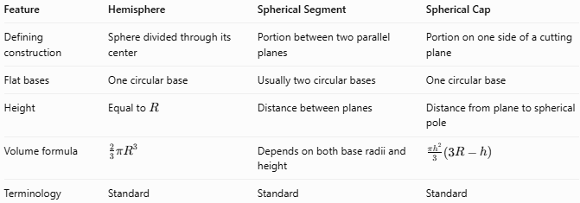
Feature | Hemisphere | Spherical Segment | Spherical Cap
Defining construction | Sphere divided through its center | Portion between two parallel planes | Portion on one side of a cutting plane
Flat bases | One circular base | Usually two circular bases | One circular base
Height | Equal to $R$ | Distance between planes | Distance from plane to spherical pole
Volume formula | $$\frac{2}{3}πR^{3}$$ | Depends on both base radii and height | $$\frac{πh^{2}}{3}\left(3R-h\right)$$
Terminology | Standard | Standard | Standard

Applications
# Source: AI Source: Provided by: [Data Path: Persons Table -> ID Column: 1, Name_En Column: Motasem Essam] -> From: [ChatGPT] on [7/25/2026]
- Architecture: Designing hemispherical domes and roof structures.
- Engineering: Modeling hemispherical ends of tanks and pressure vessels.
- Manufacturing: Calculating material requirements for hemispherical components.
- Mathematics: Studying sphere symmetry, surface area, and solid volume.
- Computer graphics: Representing hemispherical shapes and curved surfaces.

Key Points
# Source: AI Source: Provided by: [Data Path: Persons Table -> ID Column: 1, Name_En Column: Motasem Essam] -> From: [ChatGPT] on [7/25/2026]
- Hemispherical segment can be ambiguous without a precise geometric definition.
- A hemisphere is exactly half of a solid sphere.
- A hemisphere has one flat circular base and one curved surface.
- Its radius equals its height, and its base diameter equals the sphere's diameter.
- Its volume is half the volume of the original sphere.
- Its total surface area includes the flat base; its curved surface area does not.
- A solid between two parallel planes is more precisely called a spherical segment.

Conclusion
# Source: AI Source: Provided by: [Data Path: Persons Table -> ID Column: 1, Name_En Column: Motasem Essam] -> From: [ChatGPT] on [7/25/2026]
A Hemispherical Segment describes a solid section associated with a hemisphere, but the term should be defined carefully because it is less standardized than hemisphere and spherical segment. When the intended shape is exactly half a sphere, the standard term is hemisphere, with volume $\frac{2}{3}πR^{3}$ and total surface area $3πR^{2}$.

